**Drive Me Crazy**

1. Delete Sprite 1 (the cat)
2. Paint the following background as a bitmap (not a vector).

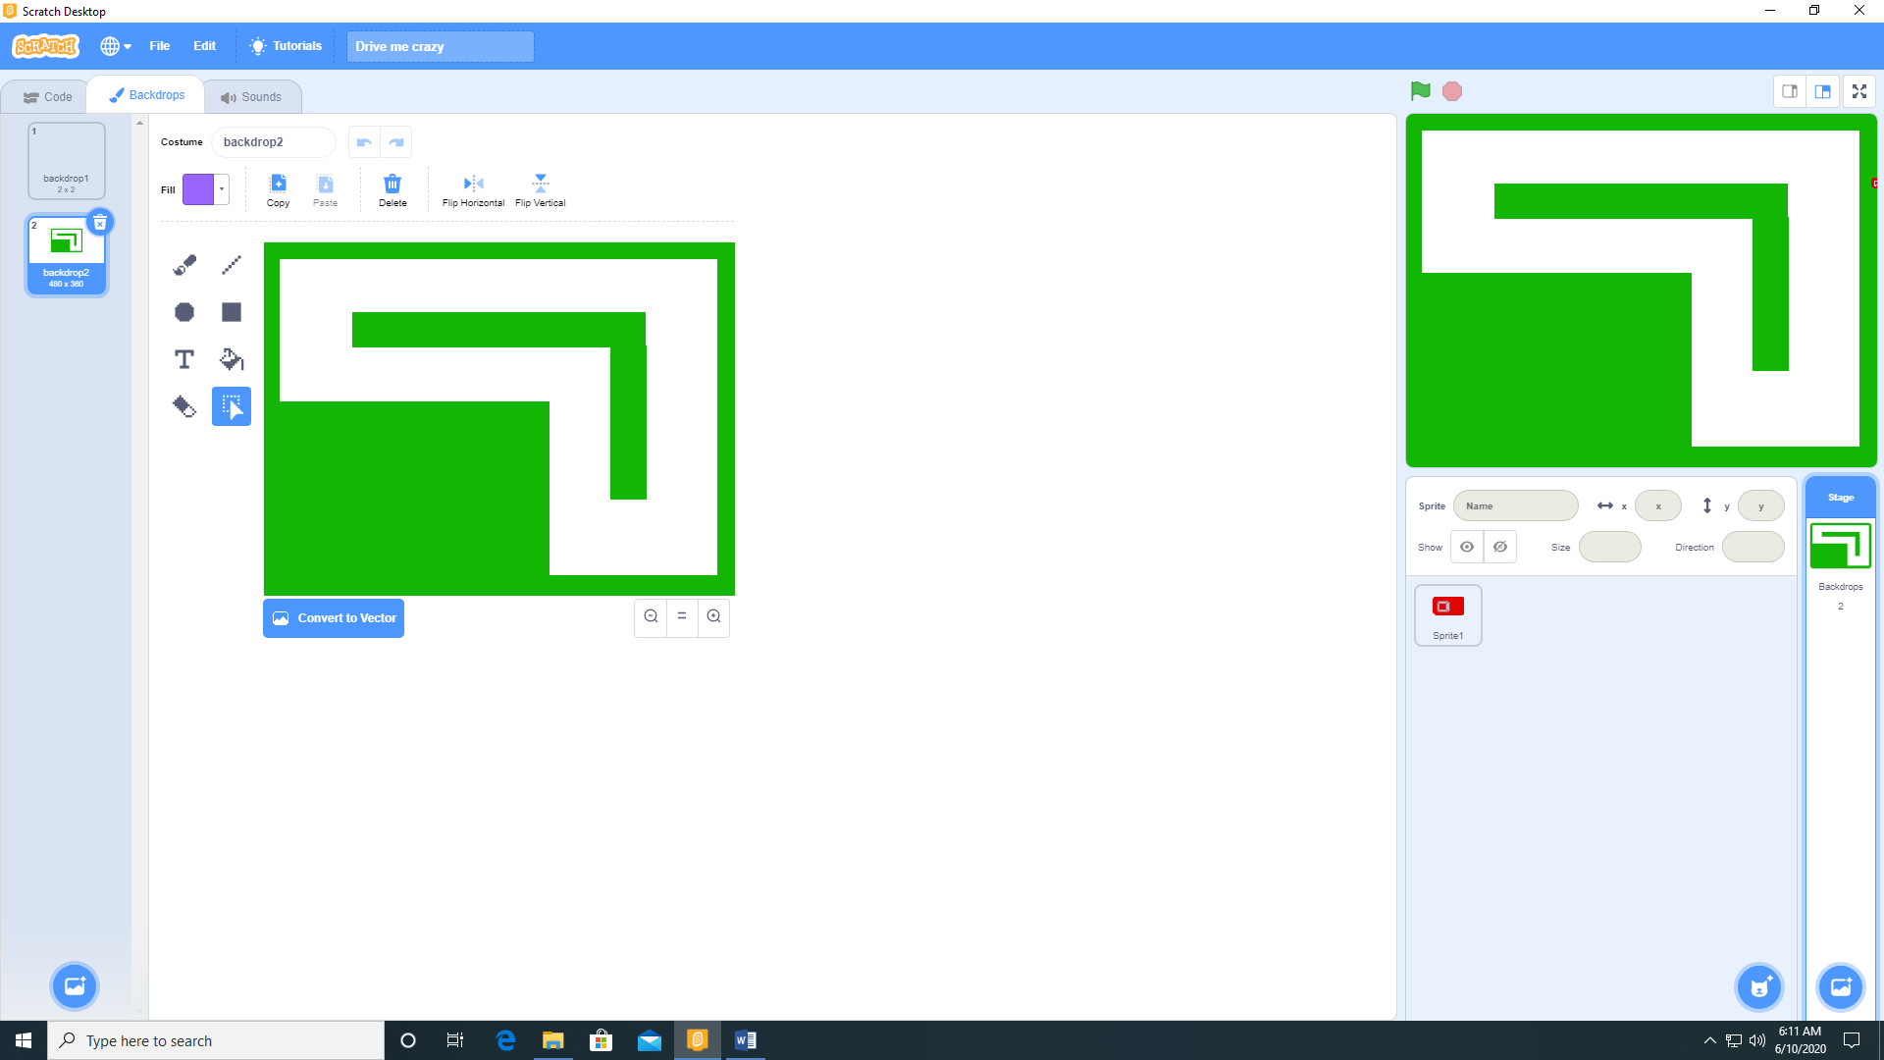

1. Paint a Car sprite as a bitmap (not a vector)

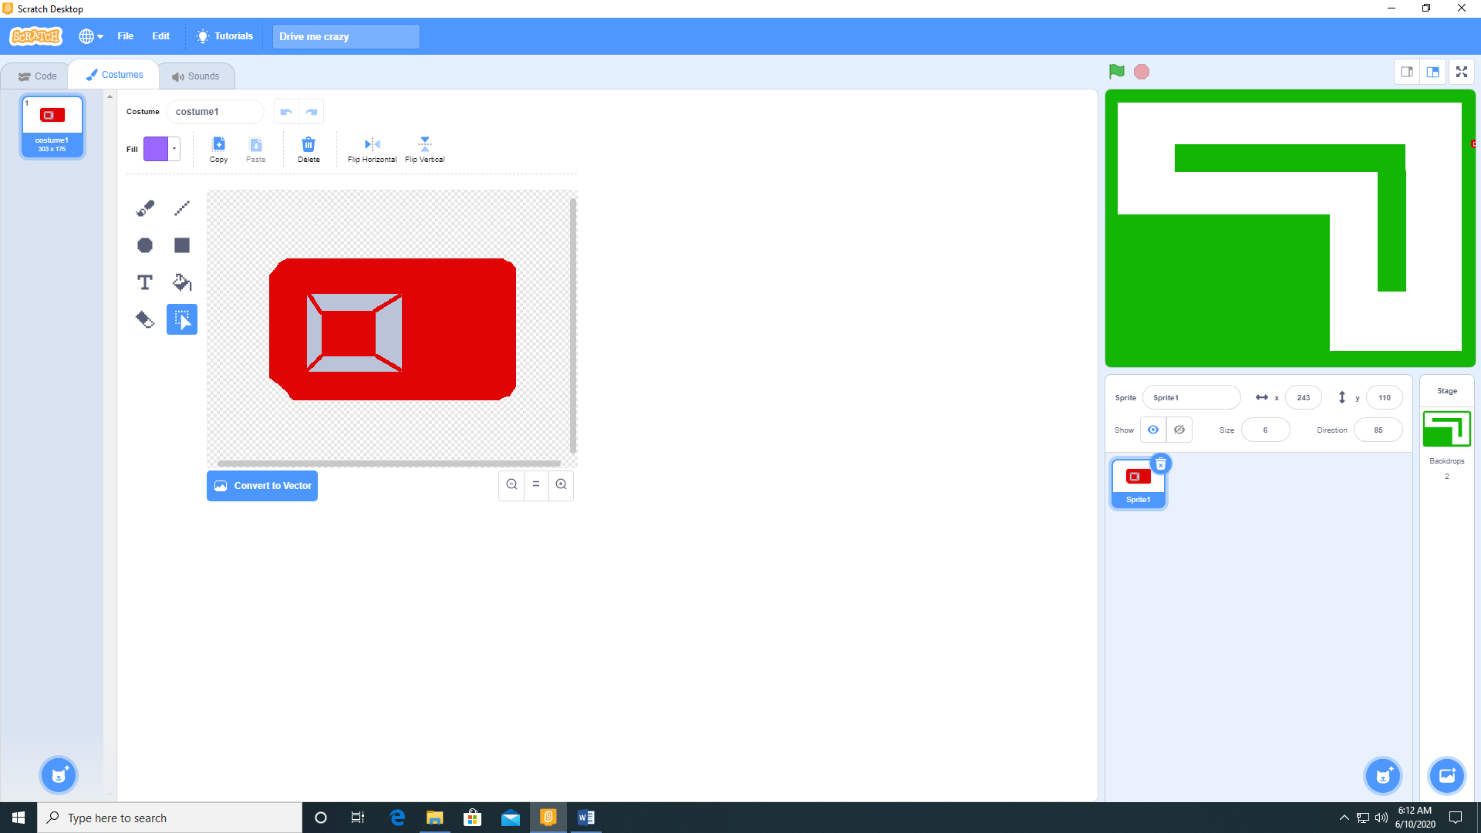

1. Add the following code to Sprite1 (the car).

